Project 0 Final Report – BIOS 6624
1 Introduction
The data for this analysis was provided by an investigator from a research group studying the endocrine system of the human body, specifically our regulation of stress. 31 study participants collected saliva samples four times a day for three days, totaling 372 samples. Individuals were instructed to collect an initial sample at waking and then three additional samples: 30 minutes later, just before lunch, and 600 minutes later. Samples were collected using strips of filter paper. Each participant was given a Saliva Procurement and Integrated Testing (SPIT) booklet to store the strips of filter paper. The SPIT booklet was stored in a large plastic bottle with an electronic monitoring cap to note the time of sample collection. Collection times were additionally noted by the participant in the booklet. The primary outcomes of interest from the samples were levels of cortisol and DHEA, two hormones used by the body to regulate stress. The investigator aimed to analyze the change in both outcomes over time. In addition to the hormone analysis, there was interest in the accuracy of the sample collection. Agreement of the recorded times from the electronic monitoring cap with the manual noted times and subject adherence to the times outlined in the collection protocol were additional areas of interest for the investigator.
2 Methods
2.1 Data Cleaning
Prior to analysis, samples were excluded based on implausible or unreliable hormone measurements. One sample reported a cortisol level above 80 nmol/L which is considered biologically implausible. Five additional samples were missing cortisol level measurements entirely. Six samples reported identical DHEA level of 5.205 nmol/L which although not necessarily implausible, is a known detection limit of the assay and in turn may be inaccurate. In total, 12 samples were excluded from all analyses, resulting in a final dataset of 360 samples.
All times of interest, including booklet-recorded times, electronic monitoring cap times and wake-up times, were converted to minutes for consistency and feasibility of future calculations. For the initial assessment of agreement between booklet and cap times, an additional 81 samples missing either booklet or cap times were excluded. For the remaining analysis, booklet times were used to minimize sample exclusion due to missingness. Under this approach, 319 samples were considered. All were considered for the hormone analysis, while 158 were included in the adherence analysis since focus was on samples two and four of each day.
2.2 Statistical Analysis
For the evaluation of the agreement between booklet and cap time, a linear mixed-effects model (LMM) was fit with random intercepts for subjects. Cap time was treated as the outcome with booklet time as the predictor. Model assumptions of normality and homoscedasticity were assessed using diagnostic plots. Agreement between the two time measures was evaluated by examining whether the fixed-effect intercept was equal to 0 and the slope equal to 1. Any deviations from these values were interpreted as evidence of systematic bias.
Using the converted wake-up time, a target time was calculated for each sample of interest. For sample two, 30 minutes was added to the wake-up time, and for sample four, 600 minutes was added. The absolute difference between booklet time and target time was then calculated for each sample. Adherence was classified as follows: good (0 - 7.5 minutes), adequate (7.5 - 15 minutes), and poor (> 15 minutes). Frequencies of adherence categories were summarized to illustrate the protocol adherence of all samples collected at these two time points.
Initial diagnostic plots were created to assess the necessity of transforming outcomes. It was determined that a logarithmic transformation of both cortisol and DHEA was appropriate. Two piecewise LMMs with random intercepts for subjects were then fitted, one for cortisol and one for DHEA. Sample time since wake-up was included as the primary indicator, with a knot at 30 minutes post-waking to capture expected changes in slope based on established hormone patterns presented by the investigator. Statistical significance was evaluated using a threshold of p < 0.05.
All data preparation and statistical analyses were conducted using R version 4.4.1.
3 Results
There were 360 samples considered for the analysis after applying exclusion criteria to the measured cortisol and DHEA values as explained previously. These samples are summarized below in Table 1. The average measured cortisol and DHEA levels across all samples collected were 5.7 nmol/L and 0.91 nmol/L, respectively. The booklet and cap times appear to be relatively similar across all sample collection times. The amount of missingness for both times is reported and cause could not be determined.
Table 1. Summary Statistics of SPIT Booklet Samples
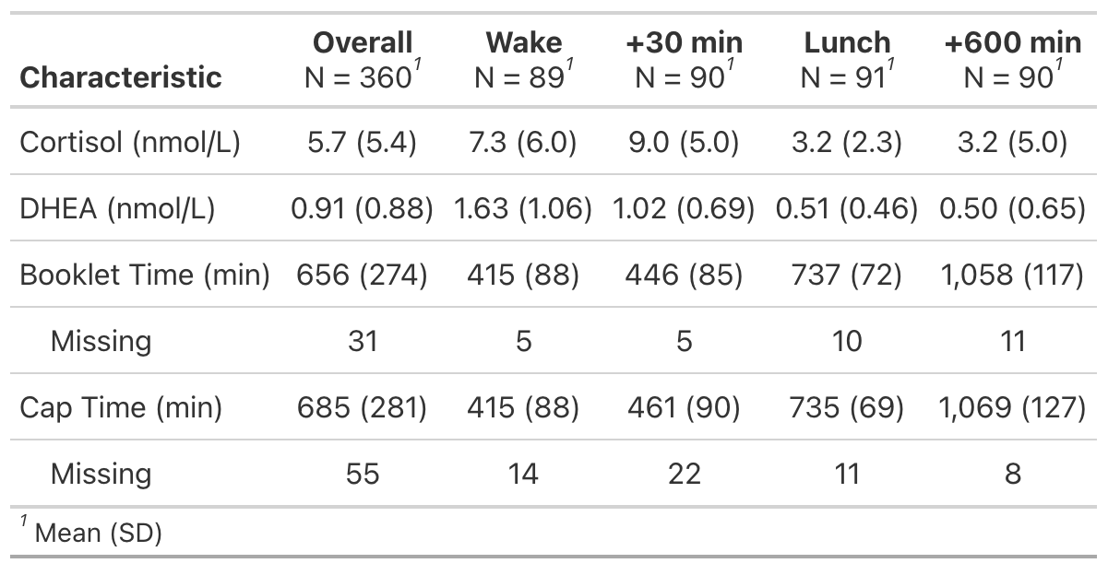

3.1 Sample Collection Time Agreement
The LMM model was fit to a dataset of 279 samples after excluding samples containing missing information. The model is visualized in Figure 1 below, with summary statistics presented in Table 2. The intercept was estimated to be 13.22 (95% CI: 2.87 to 23.56), indicating a positive bias of 13.22 minutes. In other words, this means that on average booklet time was 13.22 minutes earlier than cap time. The slope was estimated to be 0.99 (95% CI: 0.98 to 1.01) indicating that on average for every 1-minute increase in booklet time, there was a corresponding 0.99-minute increase in cap time.
Figure 1. Scatterplot of observed cap times versus recorded booklet times. The dashed purple line represents the ideal 1:1 relationship aimed for, the solid blue line represents the model’s predicted values.
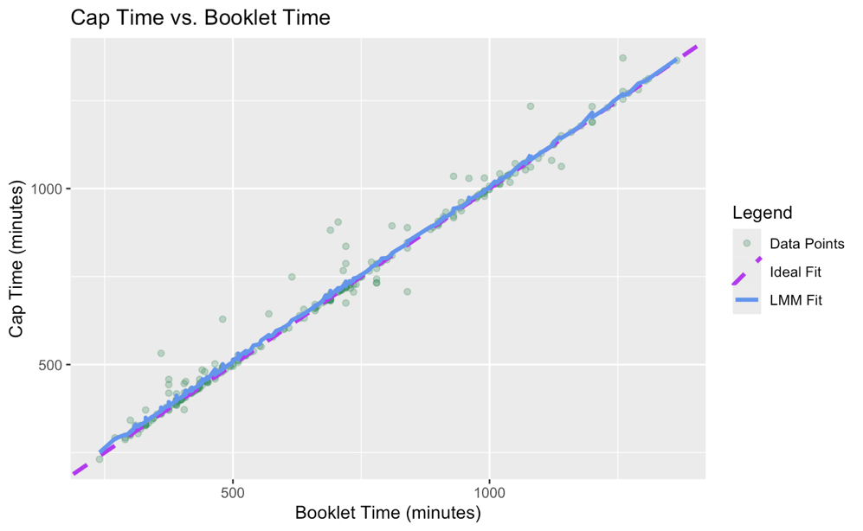
Table 2. LMM Results for Sample Collection Time Agreement Analysis
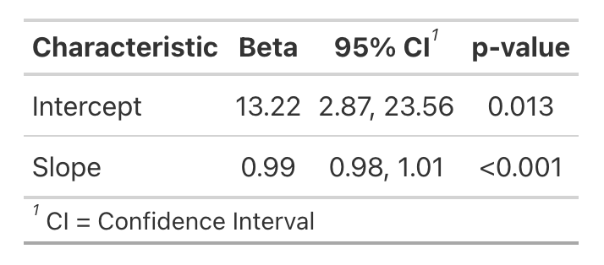
3.2 Protocol Adherence
Adherence to sample collection time protocol for each sample at the 30-minute and 600-minute times is summarized in Table 3. For the saliva samples taken 30 minutes after waking up, 78% had good adherence, 12% had adequate adherence, and 10% had poor adherence. For the saliva samples taken 600 minutes after waking up, 49% had good adherence, 8% had adequate adherence, and 43% had poor adherence.
Tabel 3. Protocol Adherence Results
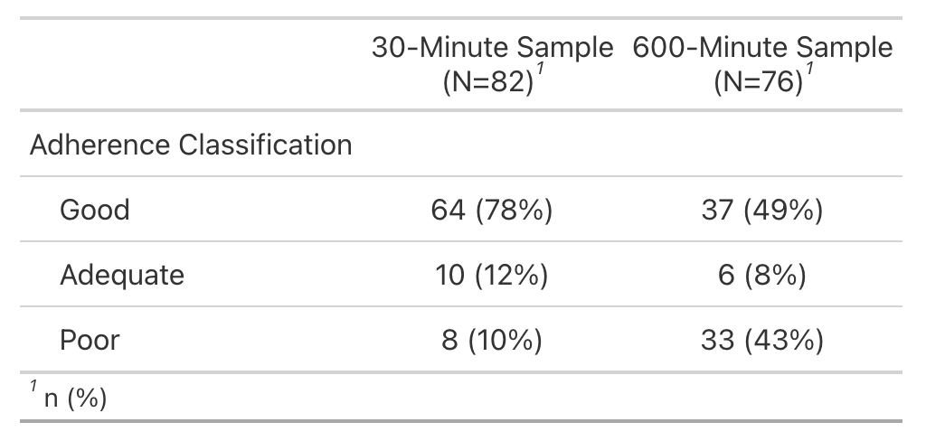
3.3 Changes over time in Cortisol & DHEA
Model fits for cortisol and DHEA are depicted in Figure 2. Time was measured in minutes since wake-up and both outcomes were log-transformed. Both models included 319 samples.
Results from the cortisol model are summarized in Table 4. From wake-up to 30 minutes post-wake, a one-minute increase in time since wake-up was associated with an estimated 0.52% increase in cortisol (95% CI: -0.23 to 1.28%), though this slope was not statistically significant (p = 0.20). After 30 minutes, a one-minute increase in time since wake-up is associated with an estimated 0.21% decrease in cortisol (95% CI: -0.25% to -0.18%), which was statistically significant (p < 0.001). Overall, the point estimates suggest an initial rise in cortisol followed by a gradual decline.
Results from the DHEA model are also summarized in Table 4. From wake-up to 30 minutes post-wake, a one-minute increase in time since wake-up is associated with an estimated 1.78% decrease in DHEA (95% CI: -2.38% to -1.18%). After 30 minutes, a one-minute increase in sample time since wake-up is associated with a 0.15% decrease in DHEA (95% CI: -0.18% to -0.12%). Both slopes were statistically significant (p < 0.001), indicating a pattern of continued decline.
Table 4. Piecewise LMM results for Cortisol and DHEA Models
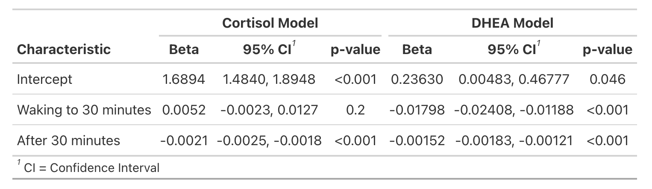
Figure 2. Individual Cortisol and DHEA measurements are plotted against time since wake-up.
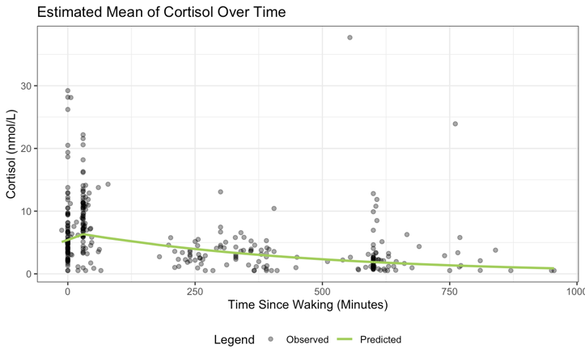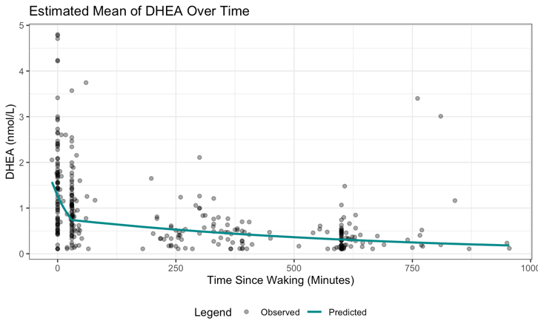
4 Discussion
Analysis of sample collection times revealed that participants’ booklet-recorded times were on average 13 minutes earlier than electronically recorded times, though the nearly 1:1 slope indicates consistent timing relative to the cap. Adherence of time protocol was highest for the 30-minute post-wake samples but substantially lower for the 600-minute samples, highlighting challenges with longer-interval collections.
The results of the hormone analysis indicate that cortisol and DHEA follow distinct diurnal patterns consistent with their roles in stress regulation. Cortisol showed a modest, non-significant increase in the first 30 minutes after waking, followed by a significant gradual decline, reflecting the typical cortisol awakening response and subsequent daily decrease. DHEA levels, in contrast, decreased significantly immediately after waking and continued to decline throughout the day. These patterns suggest that the sample collection protocol effectively captured meaningful hormonal changes, and the piecewise modeling approach with a knot at 30 minutes post-wake was appropriate for detecting time-dependent variations.
Limitations of this study include missing or excluded data, which reduced the effective sample size and may have introduced bias if excluded samples differed systematically from those retained. Potential measurement error from the use of filter paper assays, particularly near known detection limits, may have affected the accuracy of hormone measurements, especially for DHEA. In addition, adherence to the sampling protocol may have been influenced by unrecorded factors such as variability in wake-up times, delays between waking and sample collection, or participant recall error when recording booklet times.
5 Reproducible Research
All data files and analysis code relevant to this project and final report are available at: https://github.com/mmschina/BIOS6624. All code can be found specifically under Project0/Code/ReportAnalysis.rmd and the data can be found under Project0/Data/Project0_Clean_v2.csv on the local drive.

